Errors provide important feedback to users when something goes wrong. As the developer, your job is to make sure the errors you're sending along to your users make sense to them. This can be particularly challenging, since as you become more familiar with the software you're building, you will lose sight of how non-experts view your solution.

Your error messages should be informative and concise - giving some indication of what's gone wrong, and how the problem might be remedied. Something like

“It looks like you’re not connected to the internet.”

will always be better than

"ERROR 0xf172c: Unable to connect"

Adding an error code and more failure details behind a “More Information” expanding box is a good common ground, as it means users who are a bit more technically inclined can report the error code to helpdesk staff. Adding a “Contact Support” which prefills an email/contact form with the error code and other information is another good option, or do both.

Helpdesk staff and support engineers are the second important class of people who benefit from information about errors that have occurred on your application. These are people who are equipped to deal with the technical details of a particular problem. When logging errors for support staff, provide as much detail as possible so that they can find, remedy, and fix any problems they may be tasked with supporting.

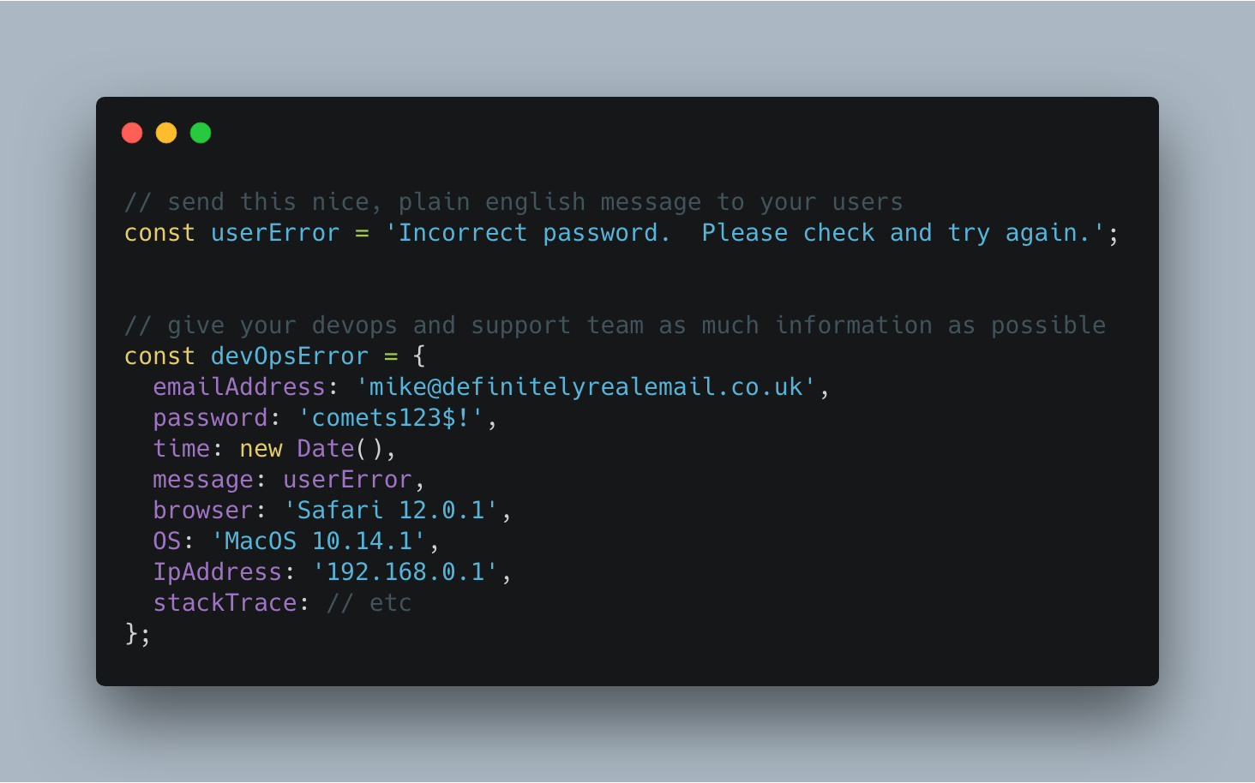
Giving your support team as much information as possible can make your helpdesk experience feel like magic.

You can also use bug tracking services like LogRocket or Sentry to silently send more contextual information to your support team in the background, to better enable their support efforts. These services can also be tied to systemwide reporting, so that as soon as an error is seen, your team is alerted to the problem. In its simplest form, this may mean sending an email to a share inbox with a bug report, or to an Incoming Webhook on Slack which posts to a shared channel. Seeing how frequently users are encountering a given error can help your engineering team prioritize bug fixes over new feature development. Being able to fix a bug before your users get disenfranchised with your product will always be easy to sell to the powers-that-be in your organization, particularly if you have data to back up your story.

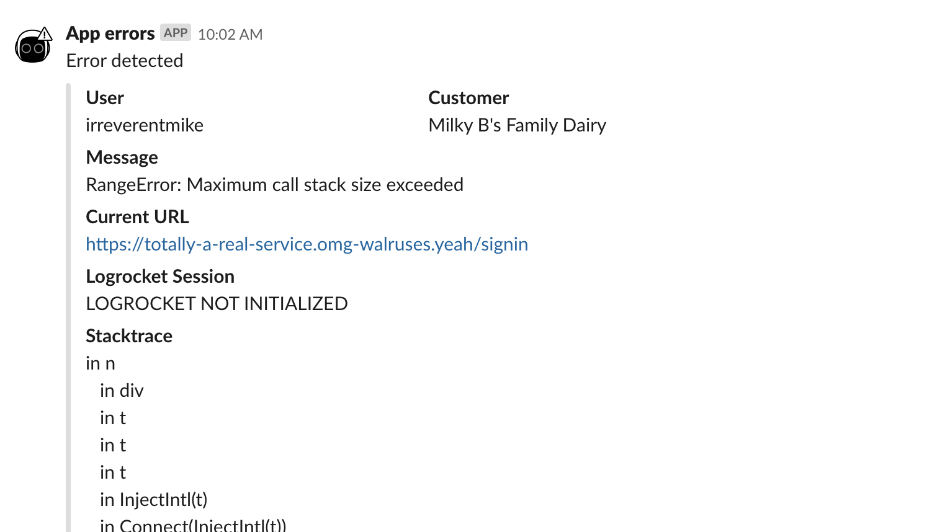
An example error report sent to a slack channel via Incoming Webhook. Seeing errors happening in real time will help your team feel empathy for how (infuriatingly) often your users encounter a given bug.

